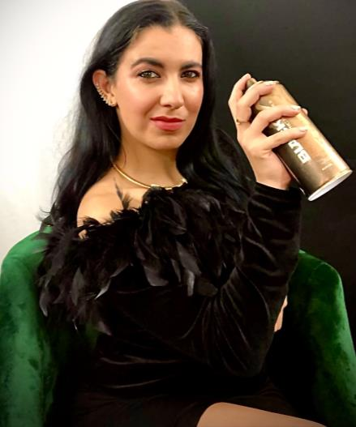

Sabrina Sadaf Smith – Resume 2022

Dallas, TX 75208 | ThinkSabrina@gmail.com | 954-997-1825

***Summary:*** Remote ready. I’m self-employed with my creative tech company and my schedule is adaptable. Looking to build & collaborate on impactful projects around the world while remaining a freelancer.

[LinkedIn Business Profile](http://linkedin.com/in/thinksabrina) / [Thinksabrina.Eth IG Profile](https://www.instagram.com/thinksabrina.eth/)

Current NFT Project: Rainbow Tribe Unite / The Honey Hive Project  
  
[AuRoom Virtual NFT Museum Headquarters](https://spatial.io/s/AuRoom-Headquarters-3-0-62c8c4e92897ef00011f0bee?share=7954455357703120226)  
  
[Opensea NFT Virtual Portfolio](https://opensea.io/auroom)  
  
[AuRoom Creative Collective - Portfolio](https://thinksabrina.wixsite.com/thinksabrina)  
  
Pitch Deck Presentations + Executive Summary Available upon Request

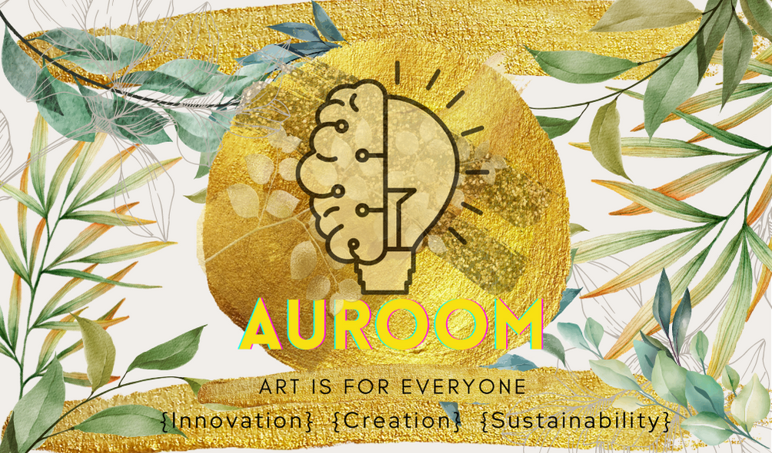

**Founder** | Auroom, LLC – Remote/ Dallas, TX | July 2018 to Present

* Creative technology incubator aiming to bring awareness to sustainability, building an ongoing digital asset collection and a long-term roadmap for a global NFT alliance project.
* Creator services in branding, marketing, & sales; Onboarding community development to work in virtual reality/the metaverse/AR, other tech, and the blockchain/cryptocurrency.
* We have a virtual gallery/growing metaverse space with Spatial.io, I act as community creative director for XR-Labs.io, and I am an NFT artist building an “Artists That Benefit the Planet” initiative. We are part of the AWorld Solutions team (aworld.org), affiliated with the United Nations.
* Solution: Empowering creatives to learn the business seamlessly, with self- management, and how to grow effectively with community leadership. By giving creators a cross-pollinated platform to collaborate on NFT project initiatives that are fair in contribution, credited, and purposeful.
* Affiliations: Startup Grind Membership, IBM Mentorship program, LiftFund, Spatial Web3 Beta Testing Community, NFT Oasis VR Community, Miami Tech/Crypto Community
* Speaker at the VR/AR Association Immerse Global Summit – October 2021, ongoing

**Creative Director** | XR-Labs, LLC – Miami, FL | Jan 2021 to Present

* A co-created ecosystem of tech professionals passionate about XR products & services
* Community leader in Miami technology/start-up community with other founders
* Consulting in guidance with marketing, sales, operations, creative direction, team building, communications, networking, and NFT marketplace business model implementation.

**Film – Assistant Producer – Apprenticeship – Miami, FL and Broward, FL**

* 8 months Cinematography and Filming Apprenticeship with Anthony P. (Epic Mn8)
* Applied to AFI Film Conservatory (Film school) with music video and script

**Artist Consultant** | Visual Arts LLC – Owner – Miami, FL | Jan 2013 to Jan 2018

* Represented emerging artists internationally and custom developed marketing strategies – tailored campaigns based on artist’s goals and milestones.
* Sustained & reached out to new business relationships during conferences i.e. Art Basel
* Managed clients’ portfolios, sales, branding – including PR, digital marketing, website development, and non-profit involvement.

**Brand Ambassador / Brand Representative** | **Events Promotions Co’s |** Jan 2012 to Dec 2015

• Provided the utmost quality of customer service during interactions with potential customers  
• Participated on teams for many events: conferences, panel discussions, international boat show, trade shows, summits, career fairs, and gallery events.

**Operations Coordinator** | **Intergi Entertainment** - Deerfield Beach, FL February 2012 to December 2012

• Managed 600+ active publishers in the network & 800+ websites related to gaming & entertainment.  
• Involved in beta testing new media player (Playwire) – collected and measured customer feedback  
• Customer Service: consistently communicated with publishers to navigate & conduct damage control; guarantee highest quality services  
• Logged any system issues in Basecamp/Highrise and Pivotal Tracker and prioritized  
• Business Development: Sustained & reached out to new business relationships (websites & publishers)  
• Promoted to upper management tasks – Managed CPM and CRM ad campaigns

**Legal Manager** | Larry Behar, P.A. - Ft Lauderdale, FL May 2014 to May 2015

* Involved with EB-5 Investor Program assistance in Canada and U.S.; managed agent and investor correspondence and developed further contacts and potential projects
* Conducted various executive assistant duties; transcribed noteworthy meetings with ambassadors, public officials, CEOs, investors, and political figures
* Maintained & drafted business plans, operating agreements, NDAs, & contracts

***Education:***

**Masters of Business Administration in Entrepreneurship** | H. Wayne Huizenga College of Business, Nova Southeastern University - Fort Lauderdale, FL | Jan 2016 to Aug 2019

**Juris Doctor Candidate** | St. Thomas University School of Law – Miami, FL | Aug 2013 to May 2015

**Bachelors of Science in Neuropsychology |** Nova Southeastern University - Fort Lauderdale, FL | August 2007 to May 2010

**Associates Degree** | College Academy At BCC - Davie, FL | August 2005 to May 2007

***Skills***

• Contracts (4 years)  
• Research (4 years)  
• MS Office Suite (6 years)

• Digital/Email Marketing

• Slack  
• Portfolio Management  
• Google Suite  
• Blogging  
• Branding  
• Content Management

• Adobe Photoshop • Salesforce  
• Communication & Presentation Skills  
 • Virtual Reality Goggles Skills

• Writing  
• Adobe Creative Suite

• Graphic Design  
• Editing  
• Creative Direction

• Art Curation  
• Networking  
• Community Building

• Speaking

***Awards***

NSU Huizenga Business School Honor Student, Alumni Scholarship, St. Thomas Law 1st Year Scholarship, Dean's List, Honors Scholarship, Florida Bright Futures Scholarship, Phi Theta Kappa Scholarship, College Academy Full Scholarship, Phi Theta Kappa Gold Membership Award

• Debate Team member, National Competition Representative at Harvard University   
  
**Management & Leadership Skills: Impact & Influence — Results: Expert** | Oct 2020

